**STAGE – 3 REPORT**

**(MEMBER TASK)**

I have chosen North Carolina state for modelling purposes. The task is to Develop Linear and Non-Linear (polynomial) regression models for predicting cases and deaths in US.

The trends of North Carolina Cases

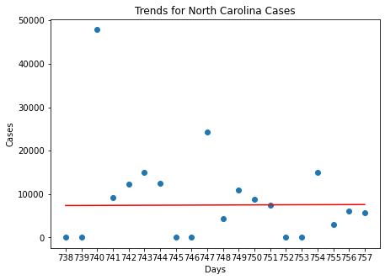

The trends of North Carolina Deaths:

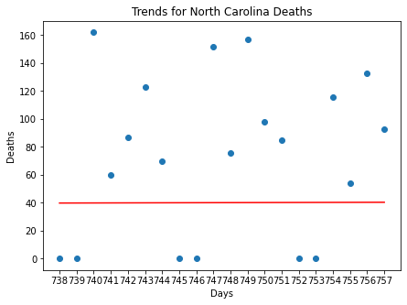

Confidence Intervals for North Carolina Cases graphs:

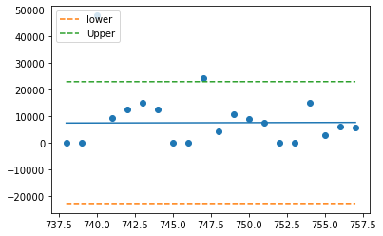

Confidence Intervals for North Carolina Deaths graphs:

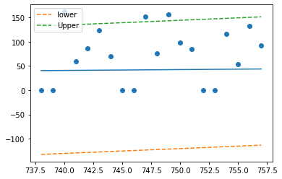

The top 5 counties with high infections are :

1. Mecklenburg County
2. Wake County
3. Guilford County
4. Forsyth County
5. Cumberland County

1. Mecklenburg County Analysis:

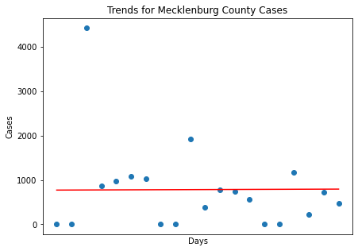

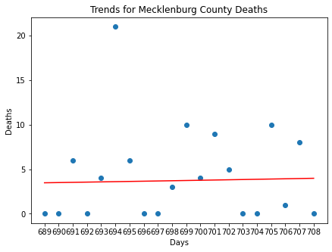

Confidence Intervals plot for Mecklenburg Cases:

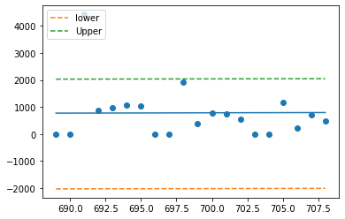

Confidence Intervals Plot for Mecklenburg Deaths:

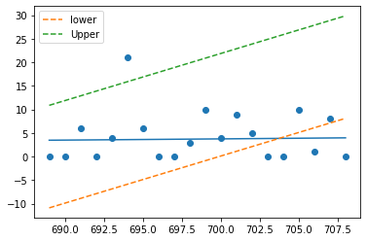

## 2. Wake County Analysis:

## 

## 

Confidence Intervals plot for Wake County Cases:

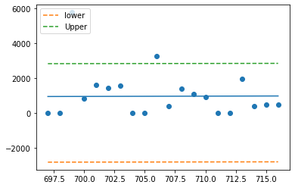

Confidence Intervals plot for Wake County Deaths:

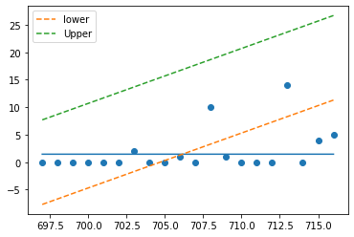

## 3. Guilford County Analysis:

## 

## 

Confidence Intervals plot for Guilford County Cases:

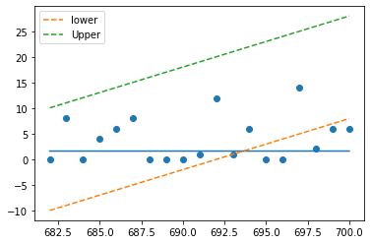

Confidence Intervals plot for Guilford County Deaths:



## 4. Forsyth County Analysis:

## 

## 

Confidence Interval Forsyth of Cases:

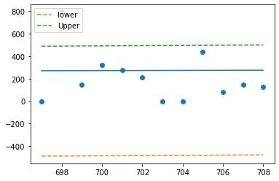

Confidence Interval Forsyth of Deaths:

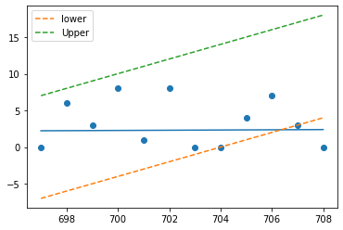

5. Cumberland County Analysis

## 

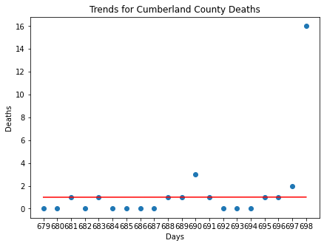

Confidence Intervals for Cases of Cumberland County:

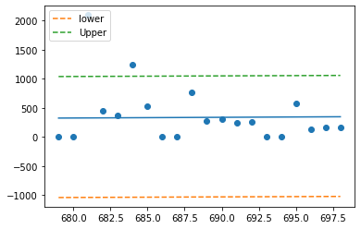

Confidence Intervals for Cases of Cumberland County:

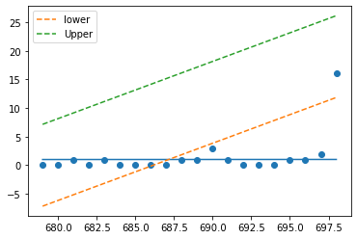

**Hypothesis Questions Analysis:**

**Conclusions**

1) Can we say the new cases can be directly related to new deaths ?

From the analysis, the p value is less than 0.05 threshold, we can reject the null hypothesis.

2) Can we say the rising or falling number of new covid cases are related to employement numbers ?

From the above analysis, the p value is less than 0.05 threshold, we can reject the null hypothesis.

3) Can we say the rising or falling new deaths are related to employement numbers ?

We can see that p value is less than 0.05 threshold, we can reject the null hypothesis.